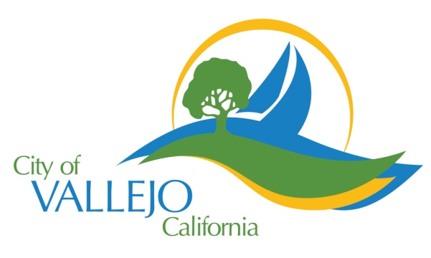
How to Purchase Parking for the Vallejo Waterfront Lots

To Purchase a Daily Permit  - Visit one of the 19 conveniently located parking kiosks (2 of which accept cash)  - Purchase via the Parkmobile smart phone app | To Purchase a  Monthly Permit  - Visit one of the 19 conveniently located parking kiosks (2 of which accept cash)  - Purchase via the City of Vallejo Monthly Parking Website (this is not the same as the Parkmobile website) | To purchase an Extended Hours Permit  - Visit one of the 19 conveniently located parking kiosks (2 of which accept cash)  - Purchase via the Parkmobile smart phone app

To Purchase a Monthly Permit on the Vallejo Monthly Parking Website:
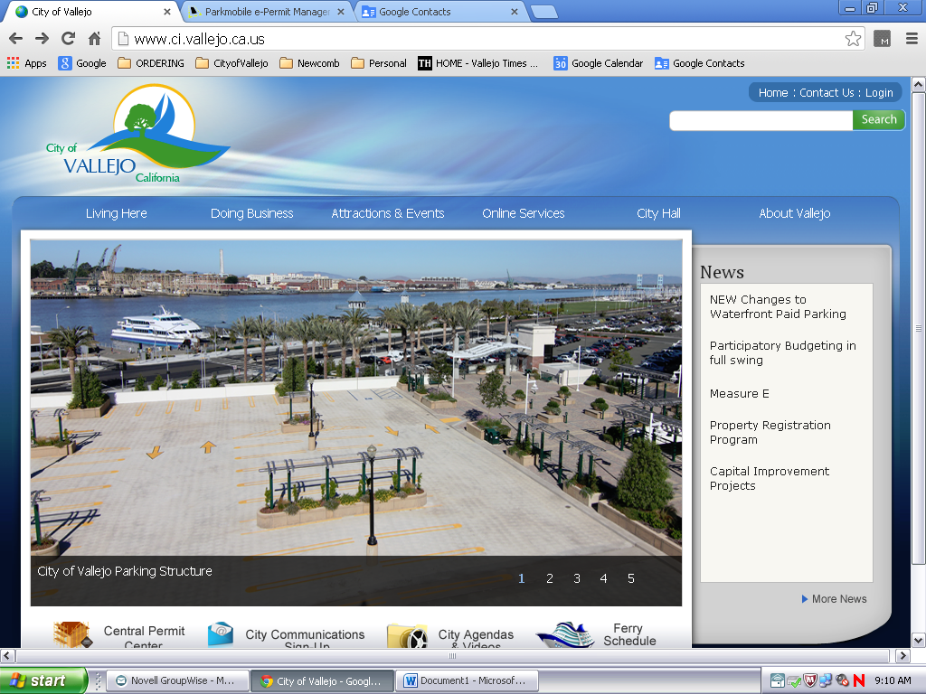
Visit the City of Vallejo Website at www.ci.vallejo.ca.us.
Click on “New Changes to Waterfront Paid Parking”

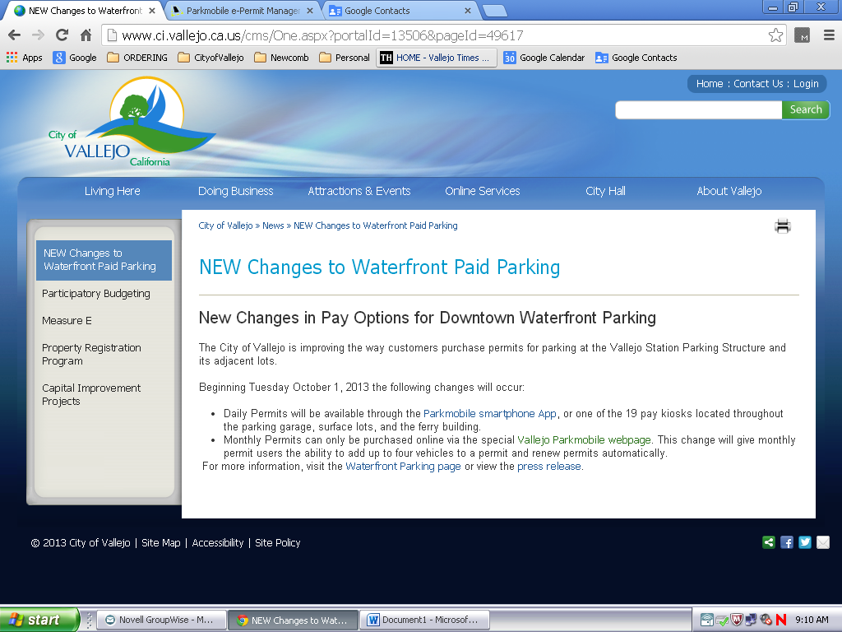
Click the link to take you to the Vallejo Parkmobile Webpage
You can also get there directly by going to https://permixx.parkmobile.us/Permixx/ClientPages/LogOnPP.aspx?SupplierID_4_CSS=64&hash=70491C6E815B17CF570429C2E598FA9F)
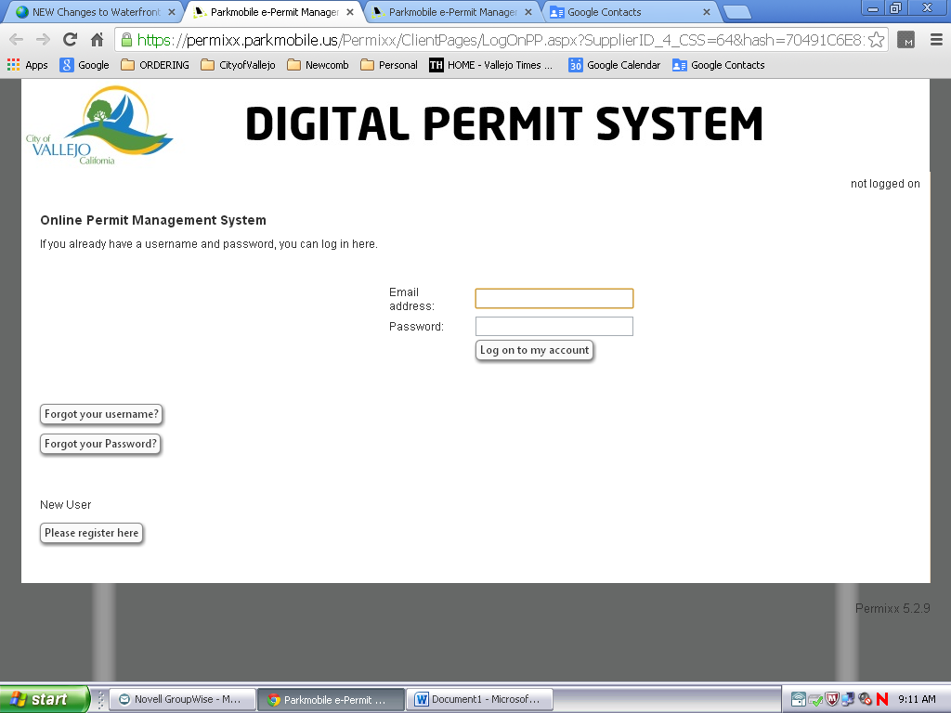
Click “Please Register Here” Even if you previously had a park mobile
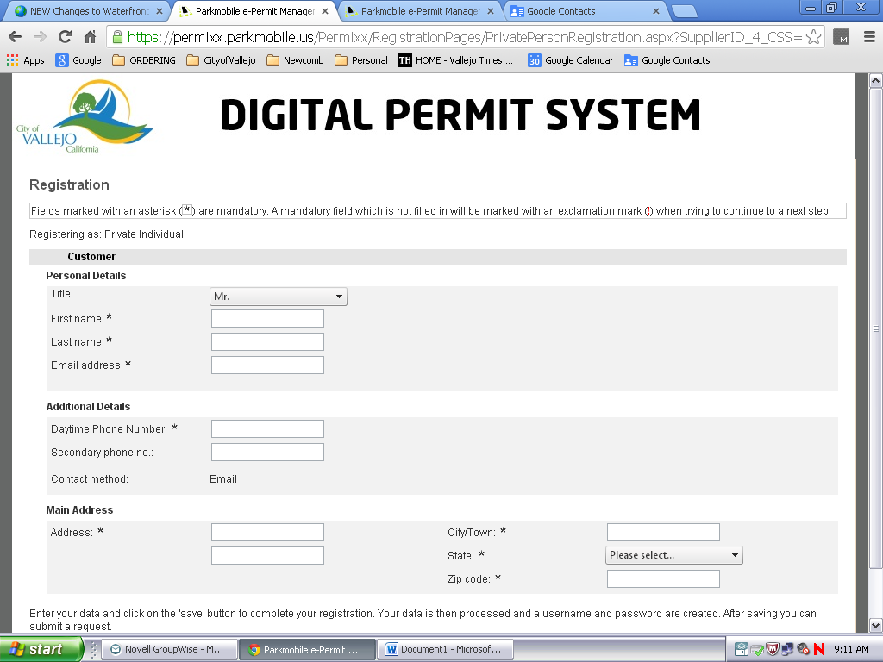
Complete form with appropriate information.

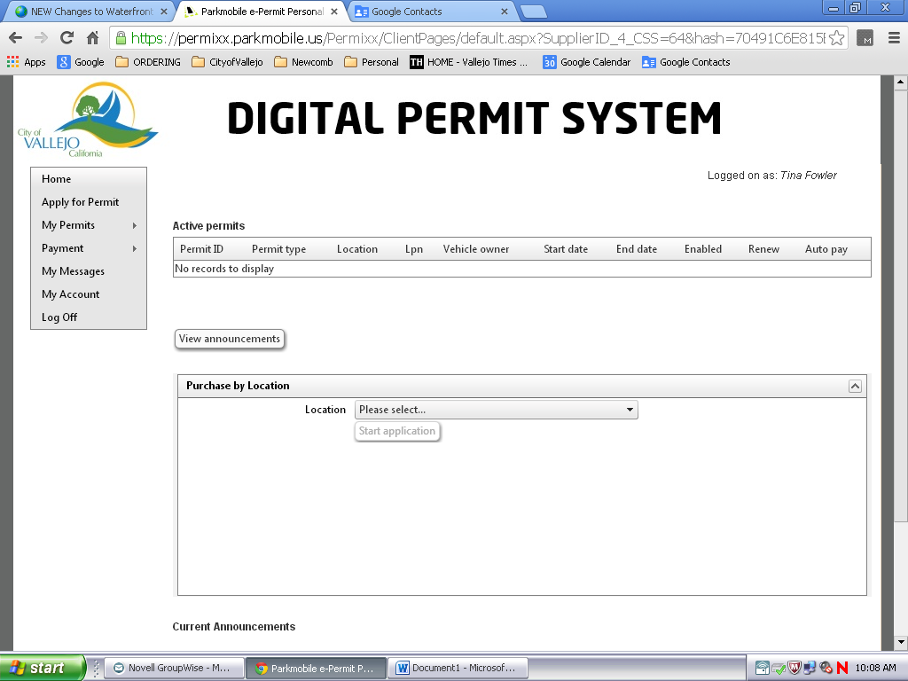
Click “Apply for Permit” .

Then click the drop down arrow next to Location and change to Vallejo Water Front Parking. Click the “Start application”button , then choose Monthly Parking Permit.
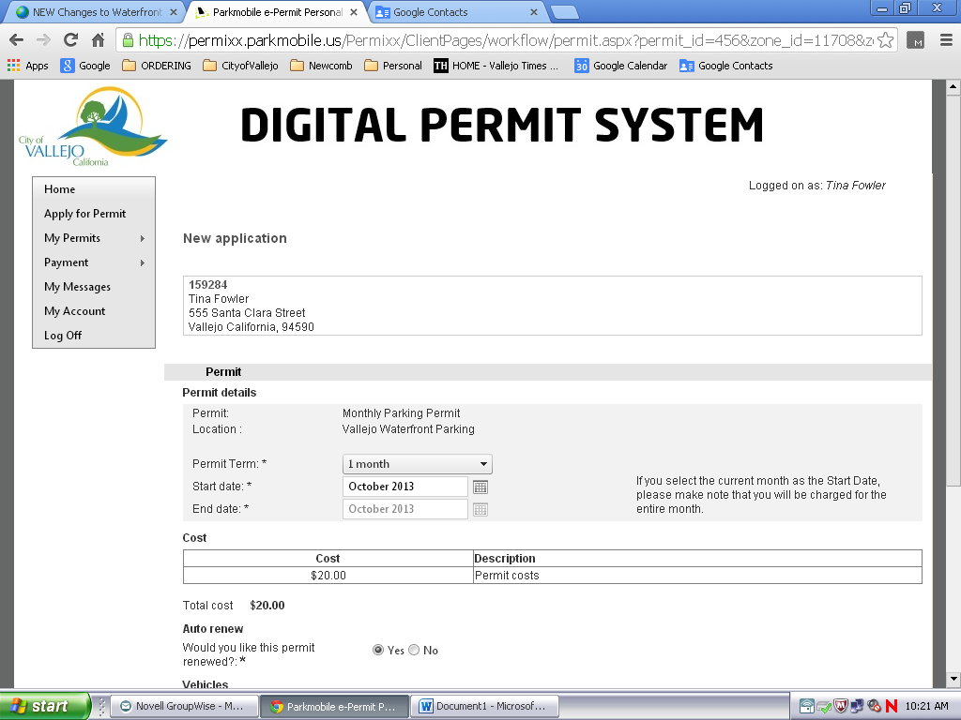
Chose the month which you are purchasing a monthly pass for. Please note that these are good for a calendar month, and not a 30day period.

Next, choose if you would like the monthly parking permit to auto renew.
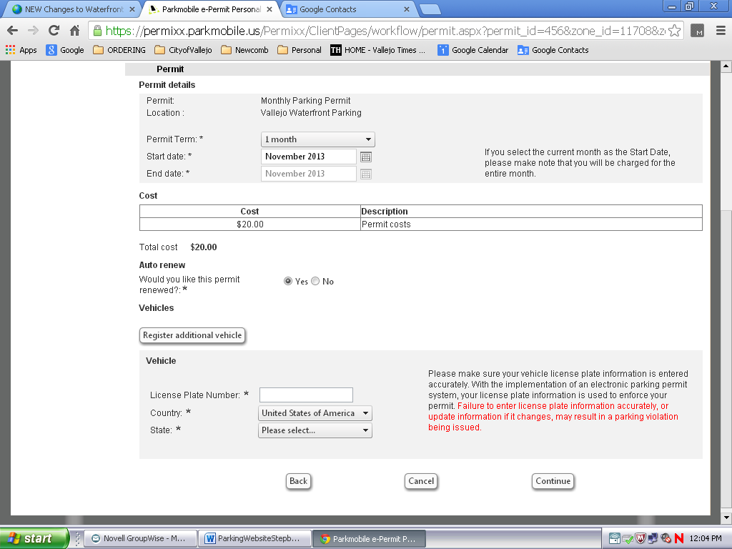
Once you have done that, register the vehicle that you want the permit for. You may register up to 4 vehicles, but only one vehicle may be in the paid parking area at any one time. You can also go back after the permit is purchased to add additional vehicles.
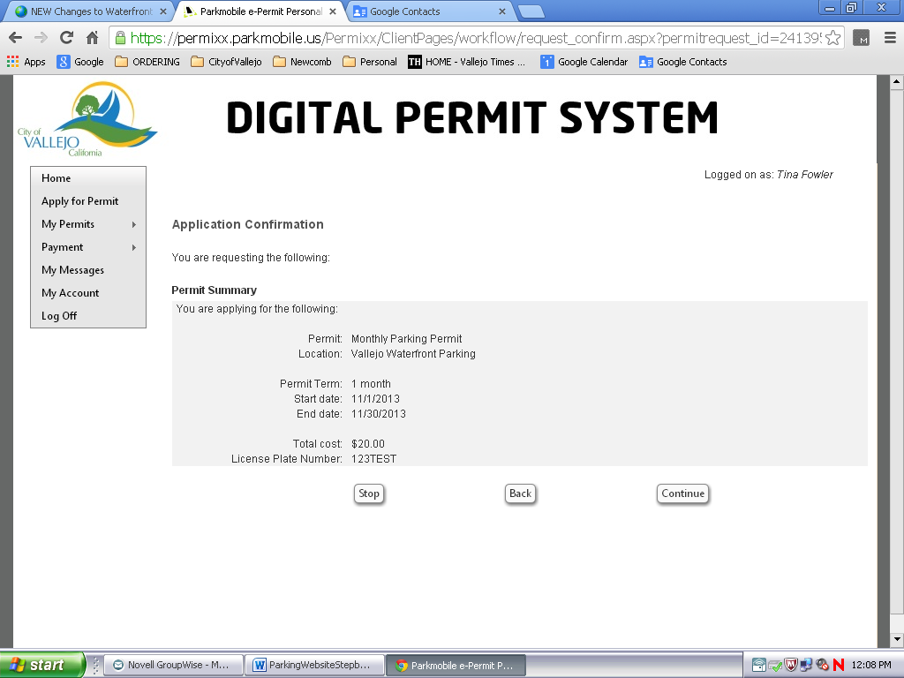
Click “Continue” on the Application Confirmation Screen.
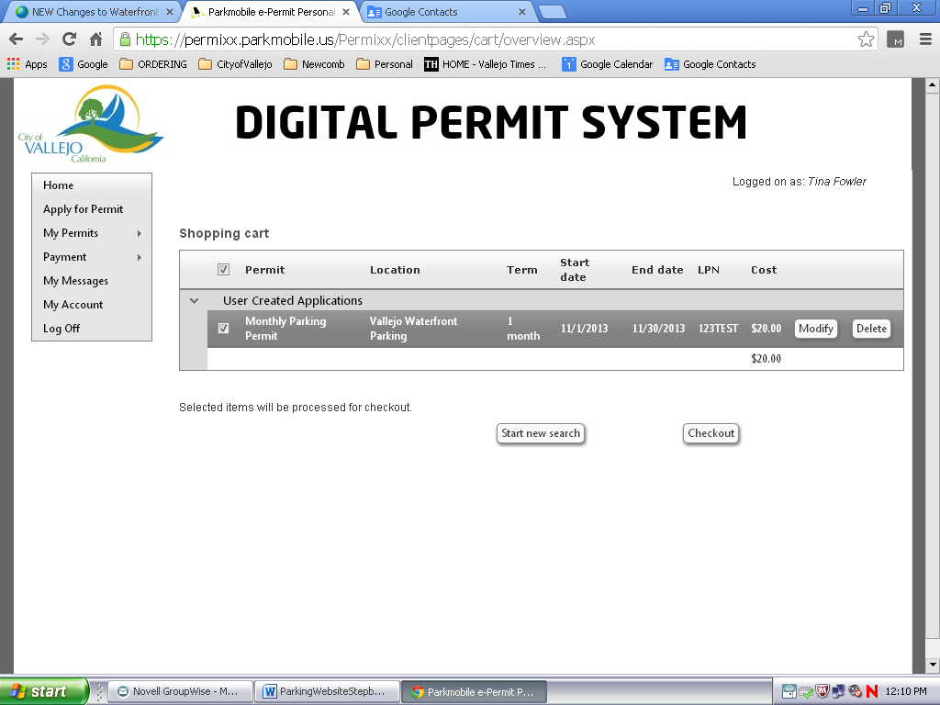
Click “Checkout” of the shopping cart.
Click “Continue” on the Application Confirmation Screen.
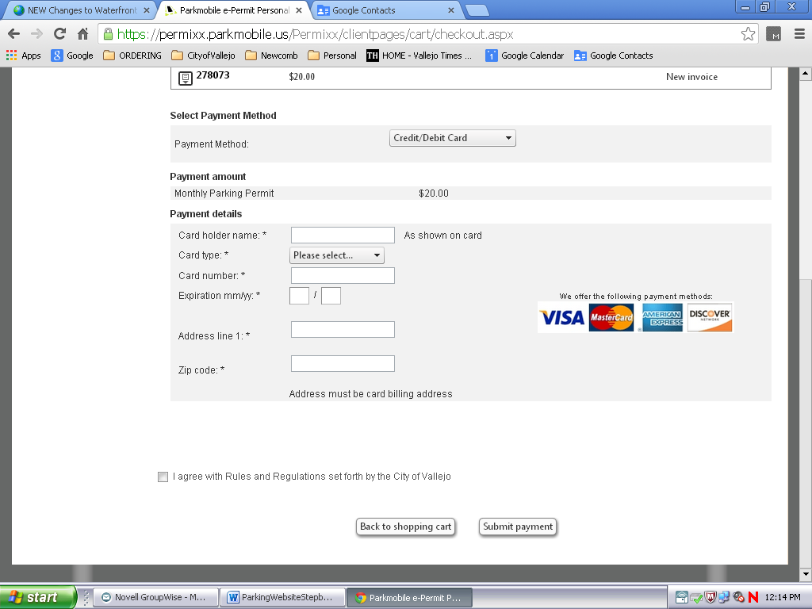
Enter your payment information, click the box that you agree with the City’s terms and submit payment.
Once this is done, you will have the opportunity to print the invoice showing you have paid for your permit. You do not need to print anything or put anything on your dash.

